Planet Shadbala Rupas Sthana Bala Kala Bala DigBala Cheshta Bala DrigBala Naisargika Bala

Sun 8.18 168.99 228.35 56.81 14.99 -23.58 60.00
Moon 6.44 180.52 134.78 14.88 11.70 4.72 51.43
Mars 5.34 184.34 62.05 32.04 36.18 -11.13 17.14
Mercury 6.09 189.72 128.77 26.14 17.66 -22.32 25.70
Jupiter 7.68 233.40 173.71 19.13 13.84 -13.49 34.28
Venus 4.80 166.15 69.39 7.74 20.31 -18.35 42.85
Saturn 8.79 278.56 162.51 56.66 31.65 -10.72 8.57

House Bhava Bala In rupas Lord's bala DigBala DrigBala

1st 420.24 7.00 320.63 30.00 69.61
2nd 289.67 4.83 288.09 20.00 -18.42
3rd 469.61 7.83 365.67 40.00 63.94
4th 528.07 8.80 386.34 60.00 81.73
5th 578.32 9.64 490.58 10.00 77.74
6th 396.39 6.61 365.67 10.00 20.73
7th 283.88 4.73 288.09 0.00 -4.21
8th 363.85 6.06 320.63 50.00 -6.78
9th 466.06 7.77 460.86 20.00 -14.80
10th 563.33 9.39 527.23 60.00 -23.90
11th 575.76 9.60 527.23 40.00 8.53
12th 556.71 9.28 460.86 20.00 75.85

House Bhava Bala In rupas Lord's bala DigBala DrigBala

1st 420.24 7.00 320.63 30.00 69.61
2nd 289.67 4.83 288.09 20.00 -18.42
3rd 469.61 7.83 365.67 40.00 63.94
4th 528.07 8.80 386.34 60.00 81.73
5th 578.32 9.64 490.58 10.00 77.74
6th 396.39 6.61 365.67 10.00 20.73
7th 283.88 4.73 288.09 0.00 -4.21
8th 363.85 6.06 320.63 50.00 -6.78
9th 466.06 7.77 460.86 20.00 -14.80
10th 563.33 9.39 527.23 60.00 -23.90
11th 575.76 9.60 527.23 40.00 8.53
12th 556.71 9.28 460.86 20.00 75.85

Planet Uchcha Rashmi Cheshta Rashmi Subha Rashmi Asubha Rashmi Ishta (Parasara) Kashta (Parasara)

Sun 8.80 5.00 3.45 4.55 24.49 35.51
Moon 9.60 4.34 3.49 4.51 24.86 35.14
Mars 7.37 9.24 4.15 3.85 31.51 28.49
Mercury 6.94 5.53 3.12 4.88 21.19 38.81
Jupiter 3.68 4.77 2.11 5.89 11.12 48.88
Venus 7.48 6.06 3.39 4.61 23.85 36.15
Saturn 13.84 8.33 5.54 2.46 45.42 14.58
Vaiseshikamsas Dasa Varga (10) Shodasa Varga (16) Sapta Varga (7) Shad Varga (6)

Sun 2-Paarijaata 2-Bhedaka
Moon
Mars 3-Uttama 6-Kerala
Mercury
Jupiter 5-Simhasana 8-ChandanaVana 3-Vyanjana 3-Vyanjana
Venus 2-Bhedaka
Saturn 3-Kusuma
Rahu 4-Gopura 4-Nagapurusha 3-Vyanjana 3-Vyanjana
Ketu 4-Gopura 7-Kalpavriksha 4-Chaamara 4-Chaamara

Planet Age Alertness (D-1) Mood (D-1)

Sun Kumara (adolescent) Sushupta (asleep) Deena (sad), Khala (mischievous)
Moon Mrita (dead) Swapna (dreaming) Duhkhita (distressed), Khala (mischievous)
Mars Vriddha (old) Swapna (dreaming) Saanta (peaceful)
Mercury Mrita (dead) Swapna (dreaming) Saanta (peaceful), Khala (mischievous)
Jupiter Kumara (adolescent) Jaagrita (awake) Swastha (comfortable), Garvita (proud)
Venus Vriddha (old) Swapna (dreaming) Duhkhita (distressed)
Saturn Vriddha (old) Jaagrita (awake) Deepta (glowing), Mudita (delighted), Garvita (proud)
Rahu Kumara (adolescent) Swapna (dreaming) Deena (sad)
Ketu Kumara (adolescent) Jaagrita (awake) Swastha (comfortable), Deena (sad), Khala (mischievous)
Planet Activity Intensity 1 Intensity 2 Intensity 3 Intensity 4 Intensity 5

Sun Kautuka (eager) Drishti (medium) Cheshta (full) Vicheshta (little) Drishti (medium) Cheshta (full)
Moon Sabha (at an assembly) Drishti (medium) Cheshta (full) Vicheshta (little) Drishti (medium) Cheshta (full)
Mars Sabha (at an assembly) Drishti (medium) Cheshta (full) Vicheshta (little) Drishti (medium) Cheshta (full)
Mercury Sayana (lying down) Cheshta (full) Vicheshta (little) Drishti (medium) Cheshta (full) Vicheshta (little)
Jupiter NrityaLipsa (desirous of dancing) Drishti (medium) Cheshta (full) Vicheshta (little) Drishti (medium) Cheshta (full)
Venus Sayana (lying down) Cheshta (full) Vicheshta (little) Drishti (medium) Cheshta (full) Vicheshta (little)
Saturn Gamana (on the move) Cheshta (full) Vicheshta (little) Drishti (medium) Cheshta (full) Vicheshta (little)
Rahu Sayana (lying down) Vicheshta (little) Drishti (medium) Cheshta (full) Vicheshta (little) Drishti (medium)
Ketu Sayana (lying down) Vicheshta (little) Drishti (medium) Cheshta (full) Vicheshta (little) Drishti (medium)

Planet Pancha-vargeeya Classification

Sun 6.90 Ordinary
Moon 6.92 Ordinary
Mars 7.24 Ordinary
Mercury 11.43 Powerful
Jupiter 14.76 Powerful
Venus 7.28 Ordinary
Saturn 12.12 Powerful

Planet Pancha-vargeeya Classification

Sun 6.90 Ordinary
Moon 6.92 Ordinary
Mars 7.24 Ordinary
Mercury 11.43 Powerful
Jupiter 14.76 Powerful
Venus 7.28 Ordinary
Saturn 12.12 Powerful

Planet Pancha-vargeeya Classification

Sun 6.90 Ordinary
Moon 6.92 Ordinary
Mars 7.24 Ordinary
Mercury 11.43 Powerful
Jupiter 14.76 Powerful
Venus 7.28 Ordinary
Saturn 12.12 Powerful

Yoga Varga Yoga givers Results ascribed to yoga Brief definition of yoga

Sasa D-1 Sa Wandering leader of free spirit Saturn in a kendra in moolatrikona or own or exaltation sign
Vosi D-1 Ju, Ve Skillful, charitable and learned Planets other than Moon in 12th from Sun
Nipuna (Budha-Aditya) D-1 Su, Me Skillful, expert, well-known and respected Sun and Mercury together or in mutual 7ths
Anaphaa D-1 Me Comforts, good looks and character Planets other than Sun in 12th from Moon
Kedaara D-1 Naabhasa yoga - throughout life Happy, wealthy, helpful and may be an agriculturalist Seven planets in 4 rasis
Chaamara D-1 Me, Ju, Ve Long-lived, scholarly, eloquent, learned in many arts Two benefics in 7th, 9th and 10th
Sankha D-1 Su, Me Wealth, good spouse and children, kind, pious, intelligent, long-lived The 5th and 6th lords in mutual kendras, strong lagna lord
Mridanga D-1 Ju, Sa King or an equal and happy Planets in own/exaltation sign in kendras/konas and strong lagna lord
Kalpadruma/Parijata D-1 Ma, Ve, Ju, Me King, principled, warrior, prosperous, strong, kind Lagna lord, his disposior, latter's rasi & navamsa dispositors are all in own/exaltation sign or kendra/kona
Saraswati D-1 Me, Ju, Ve Very learned, skillful, intelligent, famous, praised Mercury, Jupiter and Venus in kendras/konas/2nd, Jupiter in own/exaltation/friendly sign
Rajayoga D-1 Ve, Ju Successful and high achievements Conjunction, aspect or exchange of kendra/kona lords
Rajayoga D-1 Sa, Ma Successful and high achievements Conjunction, aspect or exchange of kendra/kona lords
Raja Sambandha D-1 Sa, Sa Important person in a king's court Amatya karaka conjoining/aspecting 10th lord
Raja Sambandha D-1 Sa An intelligent minister Amatya karaka in own sign or exaltation sign
Raja Sambandha D-1 Mo, Sa An associate liked by a king Amatya karaka in a kendra/kona from atma karaka
Yoga Varga Yoga givers Results ascribed to yoga Brief definition of yoga

Vosi D-9 Ju Skillful, charitable and learned Planets other than Moon in 12th from Sun
Nipuna (Budha-Aditya) D-9 Su, Me Skillful, expert, well-known and respected Sun and Mercury together or in mutual 7ths
Gaja-Kesari D-9 Mo, Ju Famous and virtuous Moon and Jupiter in mutual kendras
Daama/Daamini D-9 Naabhasa yoga - throughout life Rich, famous, helpful, many children Seven planets in 6 rasis
Kaahala D-9 Ve, Ju Strong, bold, cunning, leads a large army Jupiter and 4th lord in mutual kendras, strong lagna lord
Sankha D-9 Ma, Ju Wealth, good spouse and children, kind, pious, intelligent, long-lived The 5th and 6th lords in mutual kendras, strong lagna lord
Raja/Lakshmi D-9 Mo, Ju Fortunate and high achiever Conjunction, aspect or exchange of 1st/9th lords
Yogakaraka D-9 Ma Success and achievements Same planet owns a kendra and a kona
Rajayoga D-9 Ve, Ma Successful and high achievements Conjunction, aspect or exchange of kendra/kona lords
Raja (AK-PK) D-9 Mo, Ra Loyal following and power Atma karaka and putra karaka together or in 1st/5th
Yogada (GL) D-9 Su Power and authority Associated with lagna and GL (by aspect, conjunction or ownership)
Viparita Raja Yoga D-9 Ju Success after pressures or someone else's losses 6th lord in 8th or 12th
Raja Sambandha D-9 Mo, Ma Important person in a king's court Dispositor of amatya karaka conjoining/aspecting 10th lord

Yoga Varga Yoga givers Results ascribed to yoga Brief definition of yoga

Ubhayachara D-10 (Trd) Sa, Ju Enjoys comforts, king or an equal Planets other than Moon in 2nd and 12th from Sun
Daama/Daamini D-10 (Trd) Naabhasa yoga - throughout life Rich, famous, helpful, many children Seven planets in 6 rasis
Mridanga D-10 (Trd) Su, Ma King or an equal and happy Planets in own/exaltation sign in kendras/konas and strong lagna lord
Sarala D-10 (Trd) Ju Long-lived, fearless, learned, celebrated, prosperous The 8th lord in the 8th house
Raja/Lakshmi D-10 (Trd) Su, Ma Fortunate and high achiever Conjunction, aspect or exchange of 1st/9th lords
Yogakaraka D-10 (Trd) Ma Success and achievements Same planet owns a kendra and a kona
Yogada (GL) D-10 (Trd) Su Power and authority Associated with lagna and GL (by aspect, conjunction or ownership)
Yogada (GL) D-10 (Trd) Ma Power and authority Associated with lagna and GL (by aspect, conjunction or ownership)
Rajayoga D-10 (Trd) Su, Mo Successful and high achivements Lagna lord aspects lagna from own/exaltation sign and 6th/8th/12th lord is debilitated
Viparita Raja Yoga D-10 (Trd) Sa, Mo Success after pressures or someone else's losses The 6th and 12th lords in conjunction or samasaptaka
Raja Sambandha D-10 (Trd) Mo, Sa An associate liked by a king Amatya karaka in a kendra/kona from atma karaka
Yoga Varga Yoga givers Results ascribed to yoga Brief definition of yoga

Ubhayachara D-2 (US) Me, Ve Enjoys comforts, king or an equal Planets other than Moon in 2nd and 12th from Sun
Daama/Daamini D-2 (US) Naabhasa yoga - throughout life Rich, famous, helpful, many children Seven planets in 6 rasis
Sadhu D-2 (US) Me, Ju A saintly person Only benefics in the 3rd and 6th from AL
Rajayoga D-2 (US) Sa, Ma Successful and high achievements Conjunction, aspect or exchange of kendra/kona lords
Maha Yogada D-2 (US) Ju Power, authority and wealth Associated with lagna, GL and HL (by aspect, conjunction or ownership)
Viparita Raja Yoga D-2 (US) Me Success after pressures or someone else's losses 6th lord in 8th or 12th
Viparita Raja Yoga D-2 (US) Me, Ma Success after pressures or someone else's losses The 6th and 8th lords in conjunction or samasaptaka
Raja Sambandha D-2 (US) Sa, Sa Important person in a king's court Amatya karaka conjoining/aspecting 10th lord
Raja Sambandha D-2 (US) Mo, Sa An associate liked by a king Amatya karaka in a kendra/kona from atma karaka

Rasi
+-----------------------------------------------+
| \ / \ / |
| \ Ra / \ / |
| \ / \ / |
| \ / \ / |
|Gk \ / \ / |
|HL Md x As x Mo |
| / \ / \ |
| / \ / \ |
| / \ / \ |
| / \ 1 / Me \ |
| / \ / \ |
| x Su |
| \ / \ / |
| \ / \ AL / |
| \ / \ / |
| \ / Sa \ / |
| \ / \ / GL |
| x Ma x Ve Ju |
| / \ / \ |
| / \ / \ |
| / \ / \ |
| / \ / Ke \ |
| / \ / \ |
+-----------------------------------------------+

Rasi
+-----------------------------------------------+
| \ / \ / |
| \ Ra / \ / |
| \ / \ / |
| \ / \ / |
|Gk \ / \ / |
|HL Md x As x Mo |
| / \ / \ |
| / \ / \ |
| / \ / \ |
| / \ 1 / Me \ |
| / \ / \ |
| x Su |
| \ / \ / |
| \ / \ AL / |
| \ / \ / |
| \ / Sa \ / |
| \ / \ / GL |
| x Ma x Ve Ju |
| / \ / \ |
| / \ / \ |
| / \ / \ |
| / \ / Ke \ |
| / \ / \ |
+-----------------------------------------------+

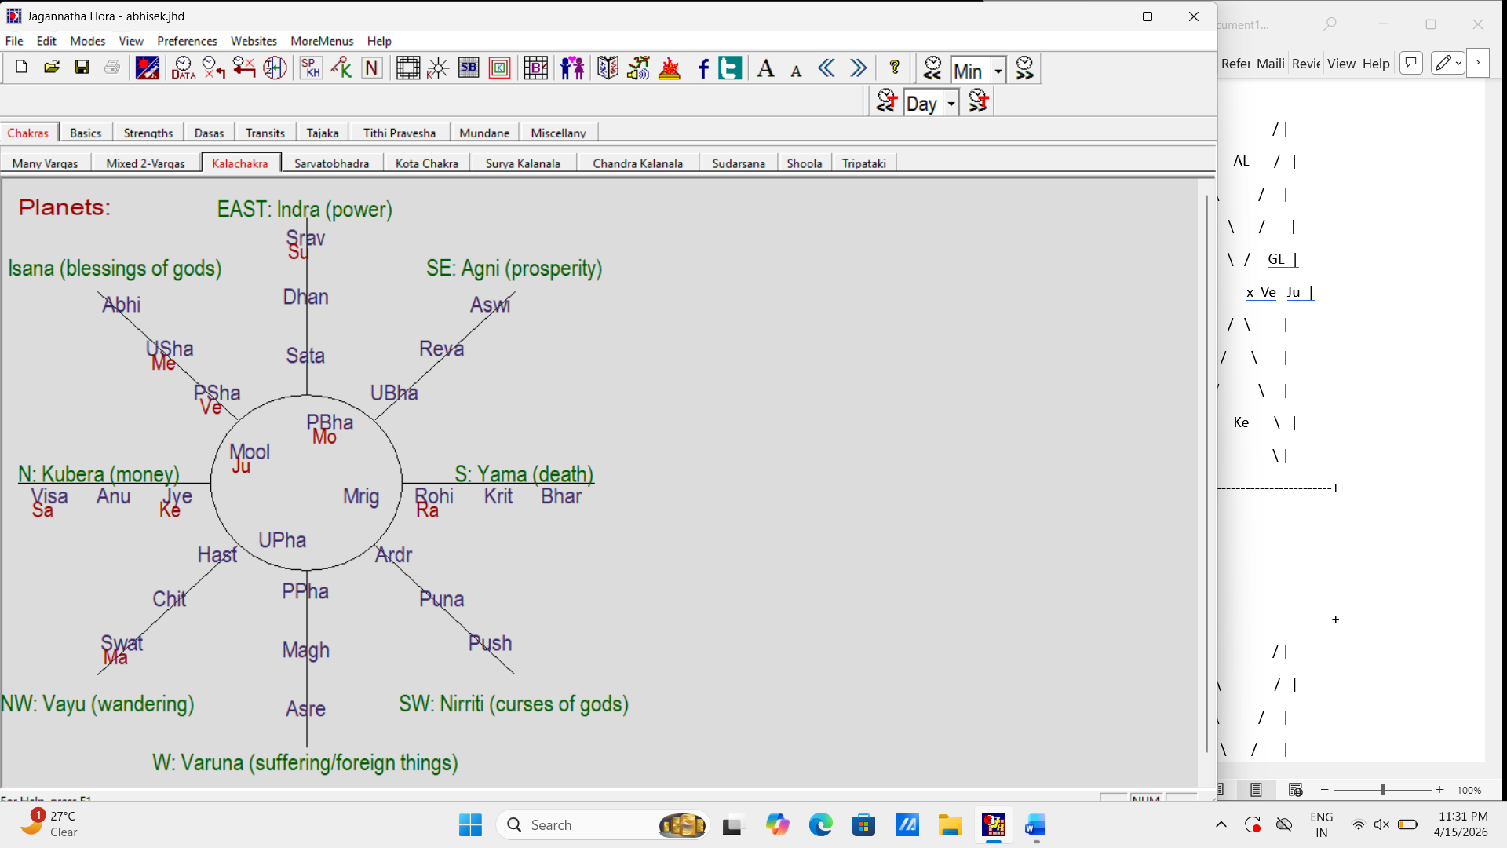

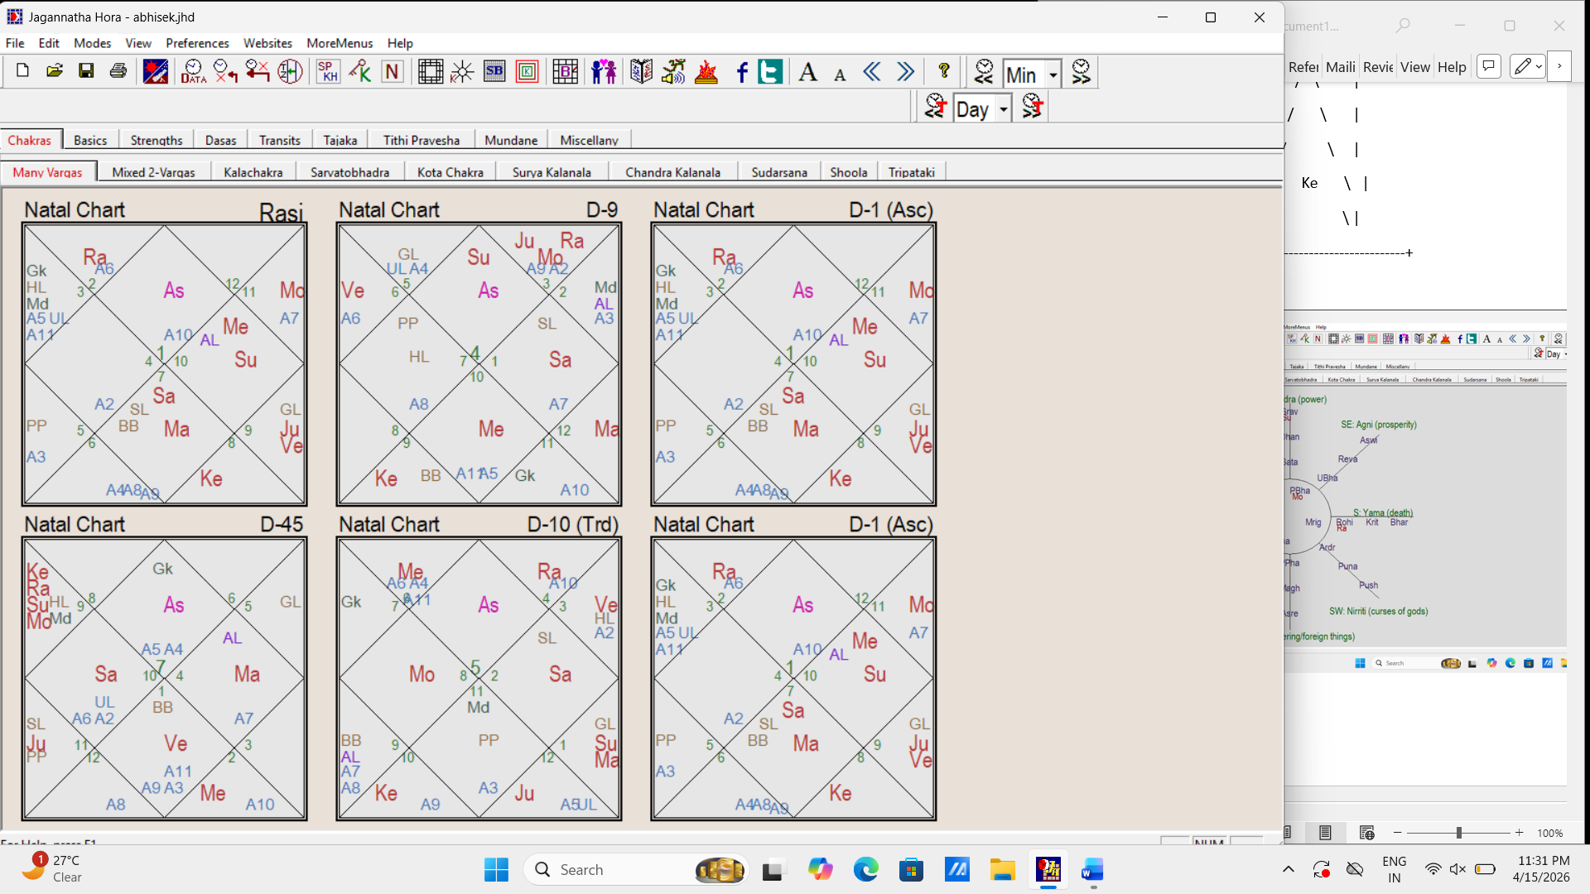

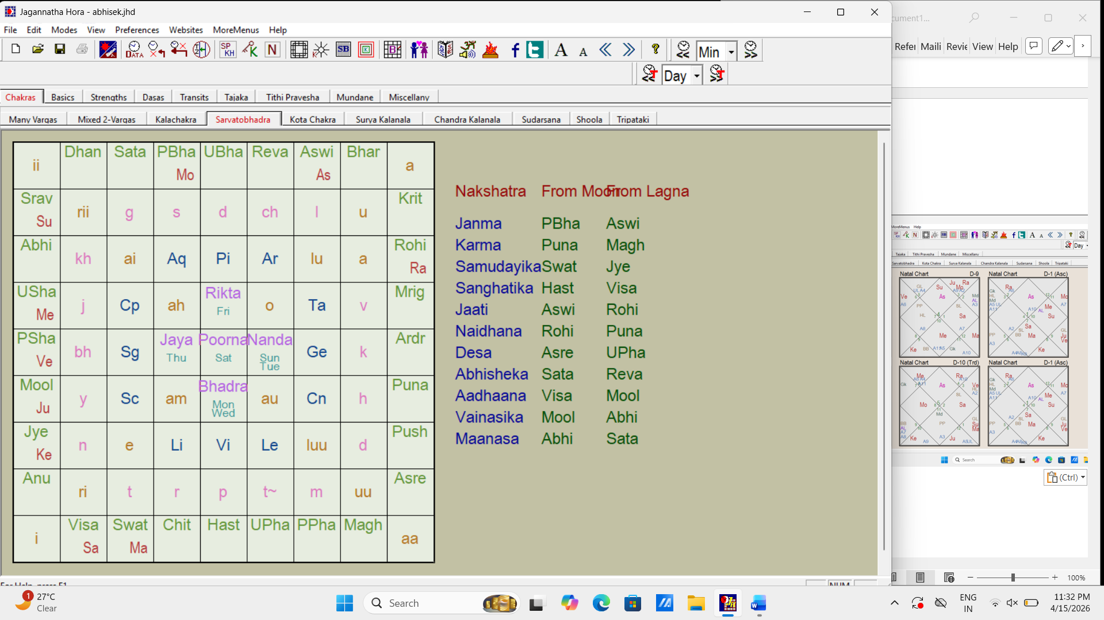

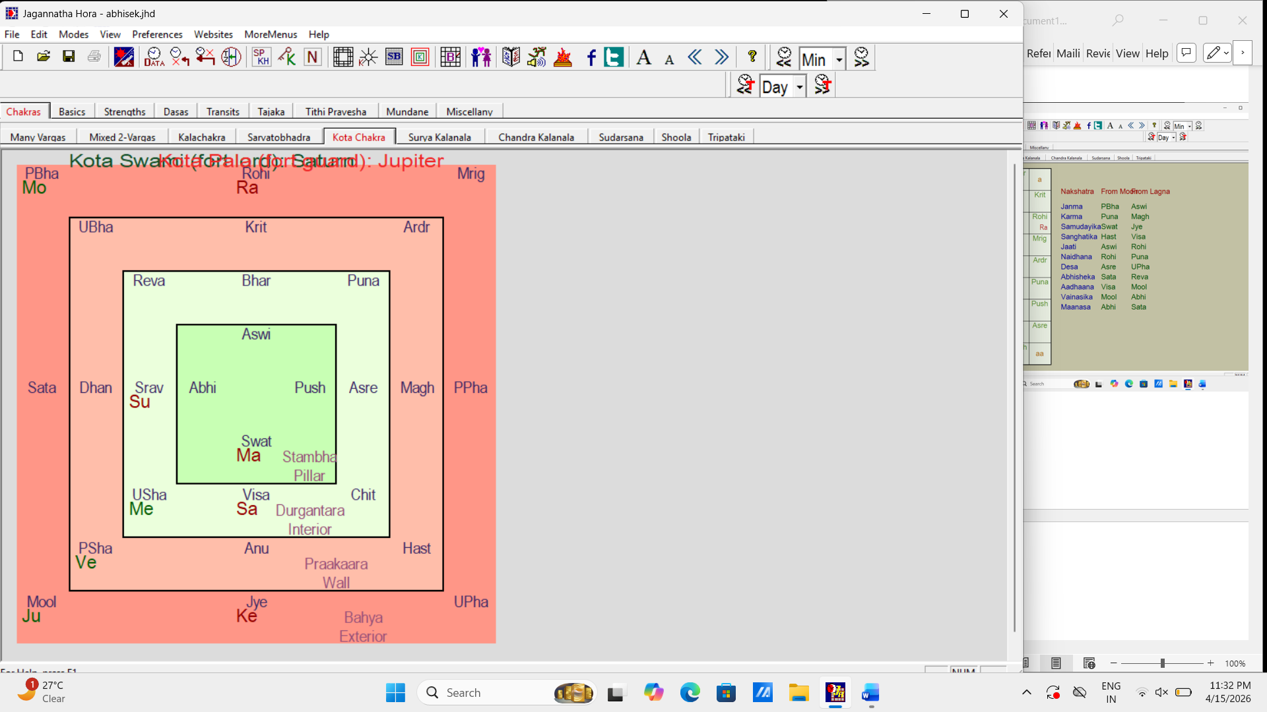

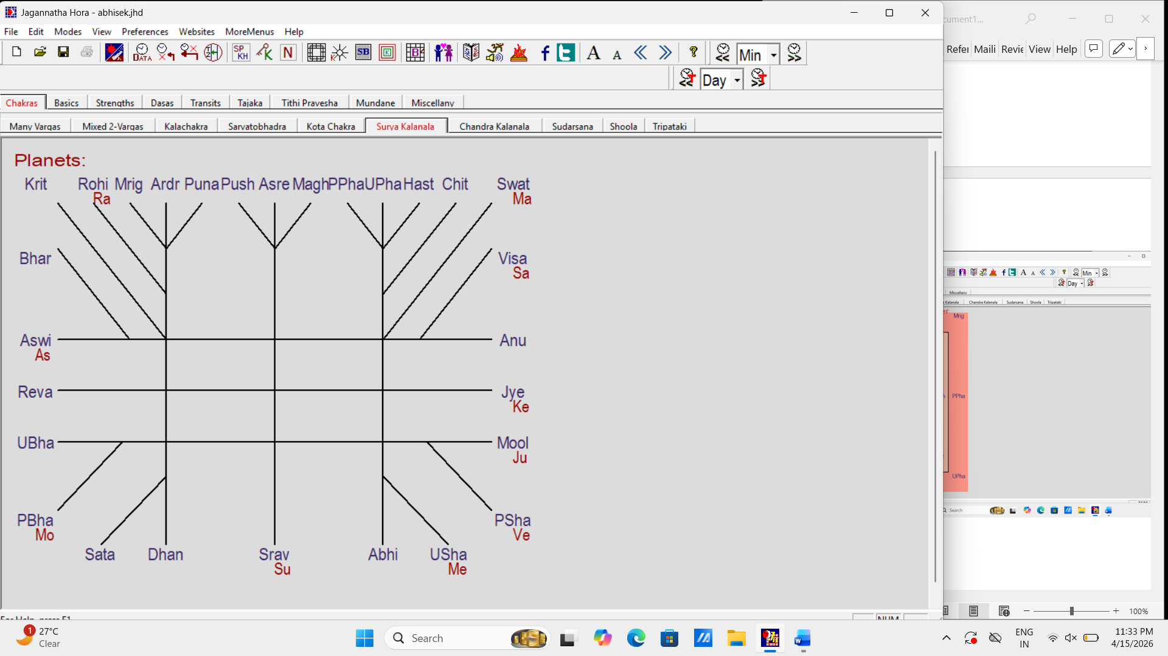

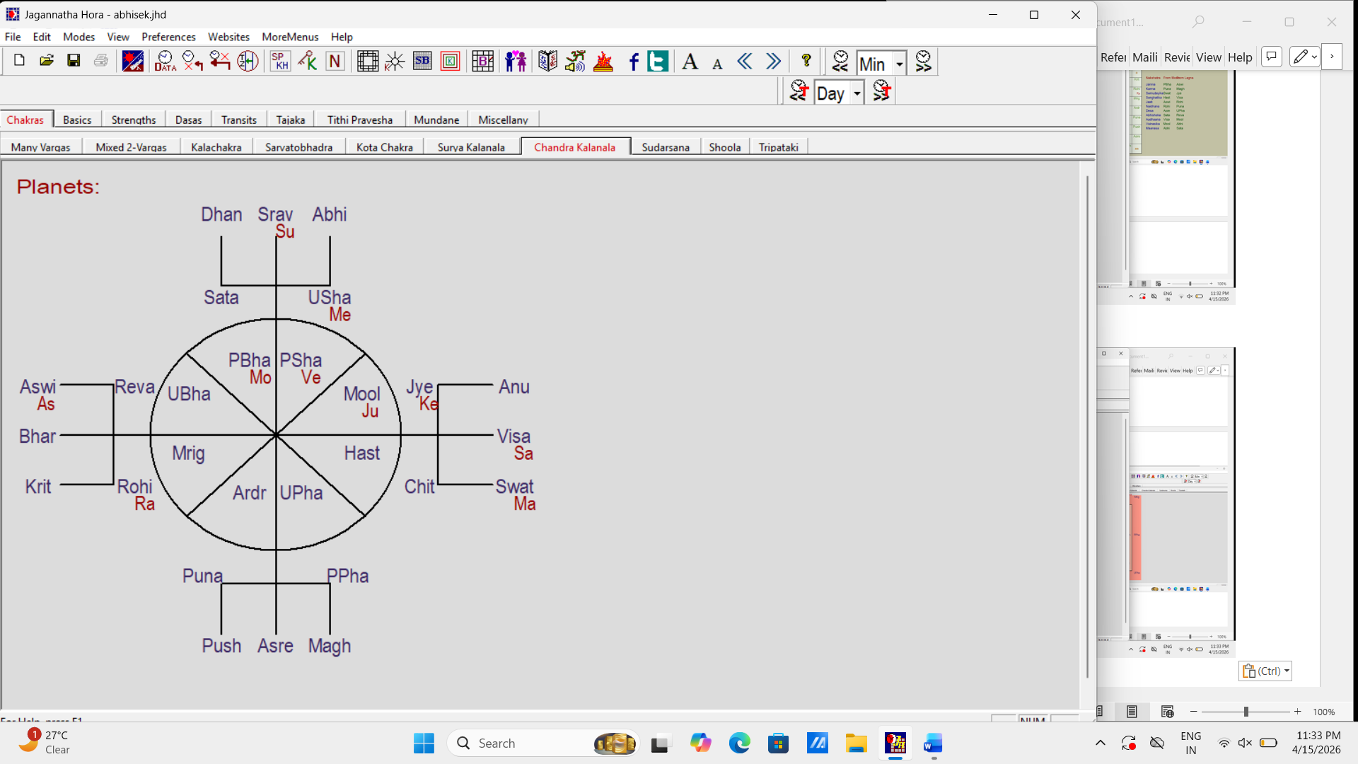



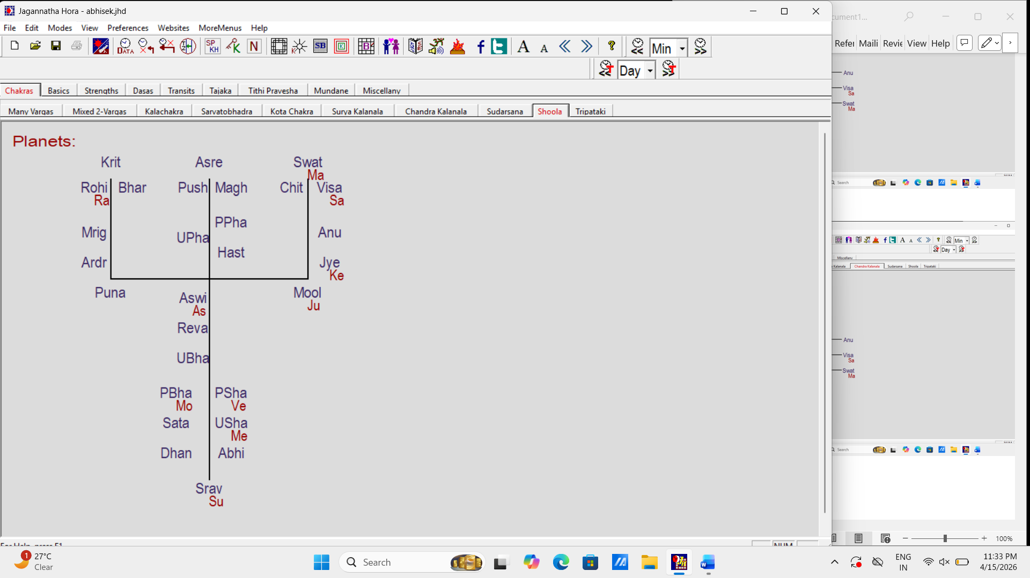

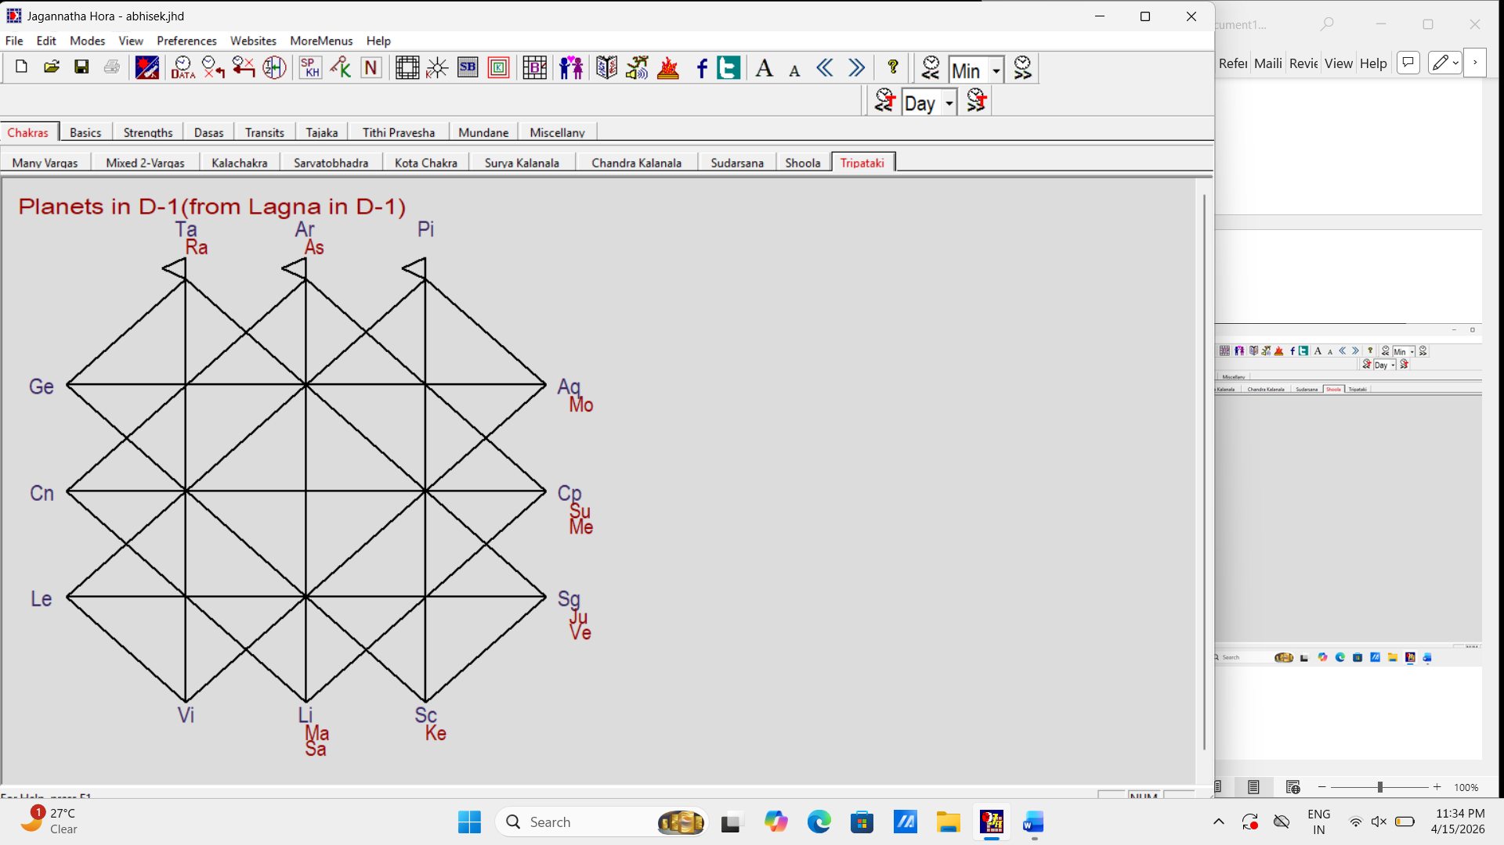

Body Longitude Nakshatra Pada Rasi Navamsa

Lagna 12 Ar 25' 21.62" Aswi 4 Ar Cn
Sun - BK 21 Cp 58' 41.37" Srav 4 Cp Cn
Moon - AK 27 Aq 04' 14.11" PBha 3 Aq Ge
Mars - PiK 18 Li 32' 04.91" Swat 4 Li Pi
Mercury - DK 0 Cp 51' 15.48" USha 2 Cp Cp
Jupiter - GK 9 Sg 48' 10.74" Mool 3 Sg Ge
Venus - MK 19 Sg 11' 17.62" PSha 2 Sg Vi
Saturn - AmK 22 Li 26' 51.25" Visa 1 Li Ar
Rahu - PK 19 Ta 02' 54.91" Rohi 3 Ta Ge
Ketu 19 Sc 02' 54.91" Jye 1 Sc Sg
Maandi 24 Ge 15' 48.32" Puna 2 Ge Ta
Gulika 14 Ge 53' 39.46" Ardr 3 Ge Aq
Bhava Lagna 26 Pi 13' 27.91" Reva 3 Pi Aq
Hora Lagna 0 Ge 39' 07.90" Mrig 3 Ge Li
Ghati Lagna 13 Sg 56' 07.87" PSha 1 Sg Le
Vighati Lagna 20 Le 21' 07.75" PPha 3 Le Li
Varnada Lagna 12 Cn 25' 21.62" Push 3 Cn Aq
Sree Lagna 23 Li 19' 42.57" Visa 1 Li Ar
Pranapada Lagna 20 Le 32' 01.21" PPha 3 Le Li
Indu Lagna 27 Sc 04' 14.11" Jye 4 Sc Pi
Bhrigu Bindu 8 Li 03' 34.51" Swat 1 Li Sg
Dhooma 5 Ge 18' 41.37" Mrig 4 Ge Sc
Vyatipata 24 Cp 41' 18.63" Dhan 1 Cp Le
Parivesha 24 Cn 41' 18.63" Asre 3 Cn Aq
Indra Chapa 5 Sg 18' 41.37" Mool 2 Sg Ta
Upaketu 21 Sg 58' 41.37" PSha 3 Sg Li
Kaala 4 Aq 09' 08.76" Dhan 4 Aq Sc
Mrityu 27 Pi 40' 57.73" Reva 4 Pi Pi
Artha Prahara 22 Ar 50' 47.89" Bhar 3 Ar Li
Yama Ghantaka 15 Ta 12' 52.04" Rohi 2 Ta Ta
Prana Sphuta 17 Le 00' 27.54" PPha 2 Le Vi
Deha Sphuta 21 Vi 27' 32.34" Hast 4 Vi Cn
Mrityu Sphuta 6 Cn 14' 17.59" Push 1 Cn Le
Sookshma TriSphuta 14 Ta 42' 17.46" Rohi 2 Ta Ta
Tithi Sphuta 5 Ta 05' 32.74" Krit 3 Ta Aq
Yoga Sphuta (Sun-Moon) 19 Sg 02' 55.48" PSha 2 Sg Vi
Rahu Tithi Sphuta 27 Cn 04' 13.54" Asre 4 Cn Pi
Kshetra Sphuta 25 Ta 24' 29.75" Mrig 1 Ta Le
Beeja Sphuta 20 Ge 58' 09.73" Puna 1 Ge Ar
TriSphuta 24 Ta 23' 15.18" Mrig 1 Ta Le
ChatusSphuta 16 Pi 21' 56.56" UBha 4 Pi Sc
PanchaSphuta 5 Ta 24' 51.46" Krit 3 Ta Aq
V2 12 Le 25' 21.62" Magh 4 Le Pi
V3 12 Sc 25' 21.62" Anu 3 Sc Aq
V4 12 Sg 25' 21.62" Mool 4 Sg Cn
V5 12 Pi 25' 21.62" UBha 3 Pi Li
V6 12 Ar 25' 21.62" Aswi 4 Ar Sc
V7 12 Cn 25' 21.62" Push 3 Cn Aq
V8 12 Le 25' 21.62" Magh 4 Le Pi
V9 12 Sc 25' 21.62" Anu 3 Sc Aq
V10 12 Sg 25' 21.62" Mool 4 Sg Sc
V11 12 Pi 25' 21.62" UBha 3 Pi Li
V12 12 Ar 25' 21.62" Aswi 4 Ar Cn
Kunda 16 Cp 14' 10.82" Srav 2 Cp Ta
Yoga Sphuta 22 Pi 22' 55.48" Reva 2 Pi Cp
Avayoga Sphuta 29 Vi 02' 55.48" Chit 2 Vi Vi

C:\Users\Abhinandan\Downloads\abhisek

Natal Chart

Date: February 5, 1984
Time: 10:43:00
Time Zone: 5:30:00 (East of GMT)
Place: 85 E 50' 00", 20 N 14' 00"
Bhubaneswar, India
Altitude: 0.00 meters

Lunar Yr-Mo: Rudhirodgaari - Magha
Tithi: Sukla Tritiya (Ma) (7.56% left)
Vedic Weekday: Sunday (Su)
Nakshatra: Poorvabhadra (Ju) (46.97% left)
Yoga: Siva (Me) (57.13% left)
Karana: Garija (Ju) (15.13% left)
Hora Lord: Saturn (5 min sign: Ta)
Mahakala Hora: Saturn (5 min sign: Cp)
Kaala Lord: Mercury (Mahakala: Mercury)

Sunrise: 6:25:17
Sunset: 17:36:18
Janma Ghatis: 10.7380

Ayanamsa: 23-37-09.78
Sidereal Time: 19:54:33

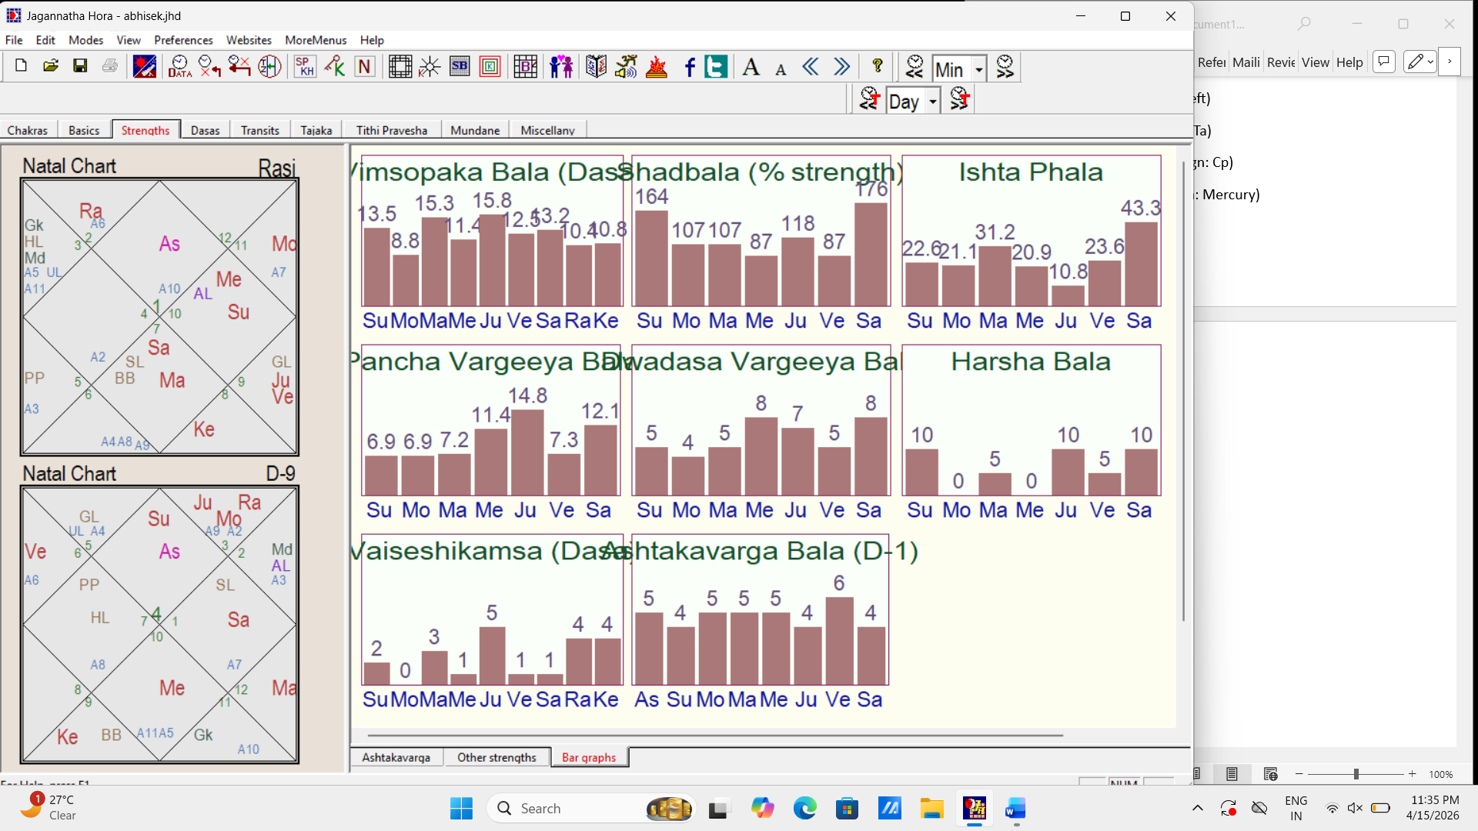

Vimsottari Dasa:

Maha Dasas:

Jup: 1975-08-14 (14:56:05) - 1991-08-14 (17:22:52)
Sat: 1991-08-14 (17:22:52) - 2010-08-14 (14:13:18)
Merc: 2010-08-14 (14:13:18) - 2027-08-14 (22:50:27)
Ket: 2027-08-14 (22:50:27) - 2034-08-14 (17:49:51)
Ven: 2034-08-14 (17:49:51) - 2054-08-14 (20:47:16)
Sun: 2054-08-14 (20:47:16) - 2060-08-14 (9:47:57)
Moon: 2060-08-14 (9:47:57) - 2070-08-14 (23:06:41)
Mars: 2070-08-14 (23:06:41) - 2077-08-14 (18:26:42)
Rah: 2077-08-14 (18:26:42) - 2095-08-15 (8:58:48)

Vimsottari Dasa:

Merc MD: 2010-08-14 (14:13:18) - 2027-08-14 (22:50:27)

Antardasas in this MD:

Merc: 2010-08-14 (14:13:18) - 2013-01-08 (20:37:00)
Ket: 2013-01-08 (20:37:00) - 2014-01-06 (4:07:32)
Ven: 2014-01-06 (4:07:32) - 2016-11-07 (18:32:09)
Sun: 2016-11-07 (18:32:09) - 2017-09-14 (10:13:40)
Moon: 2017-09-14 (10:13:40) - 2019-02-10 (20:37:55)
Mars: 2019-02-10 (20:37:55) - 2020-02-08 (3:43:46)
Rah: 2020-02-08 (3:43:46) - 2022-08-30 (5:42:13)
Jup: 2022-08-30 (5:42:13) - 2024-12-04 (13:39:12)
Sat: 2024-12-04 (13:39:12) - 2027-08-14 (22:50:27)

Vimsottari Dasa:

Merc MD: 2010-08-14 (14:13:18) - 2027-08-14 (22:50:27)
Sat AD: 2024-12-04 (13:39:12) - 2027-08-14 (22:50:27)

Pratyantardasas in this AD:

Sat: 2024-12-04 (13:39:12) - 2025-05-06 (14:41:59)
Merc: 2025-05-06 (14:41:59) - 2025-09-26 (10:38:28)
Ket: 2025-09-26 (10:38:28) - 2025-11-22 (4:54:08)
Ven: 2025-11-22 (4:54:08) - 2026-05-02 (0:33:13)
Sun: 2026-05-02 (0:33:13) - 2026-06-21 (10:34:16)
Moon: 2026-06-21 (10:34:16) - 2026-09-13 (14:56:06)
Mars: 2026-09-13 (14:56:06) - 2026-11-09 (18:41:32)
Rah: 2026-11-09 (18:41:32) - 2027-04-02 (17:02:40)
Jup: 2027-04-02 (17:02:40) - 2027-08-14 (22:50:27)

Sudasa (phalita dasa showing Lakshmi's blessings):

Maha Dasas:

Cp: 1984-02-05 (10:43:00) - 1984-12-27 (15:13:29)
Ar: 1984-12-27 (15:13:29) - 1990-12-28 (4:11:33)
Cn: 1990-12-28 (4:11:33) - 1995-12-28 (10:53:18)
Li: 1995-12-28 (10:53:18) - 1997-12-27 (23:19:55)
Sc: 1997-12-27 (23:19:55) - 2008-12-27 (18:59:17)
Aq: 2008-12-27 (18:59:17) - 2013-12-28 (1:47:42)
Ta: 2013-12-28 (1:47:42) - 2020-12-27 (20:47:13)
Le: 2020-12-27 (20:47:13) - 2027-12-28 (15:53:34)
Sg: 2027-12-28 (15:53:34) - 2039-12-28 (17:41:09)
Pi: 2039-12-28 (17:41:09) - 2042-12-28 (12:09:23)
Ge: 2042-12-28 (12:09:23) - 2049-12-28 (7:17:22)
Vi: 2049-12-28 (7:17:22) - 2057-12-28 (8:34:02)
Cp: 2057-12-28 (8:34:02) - 2069-02-05 (6:01:32)
Ar: 2069-02-05 (6:01:32) - 2075-02-05 (18:58:36)
Cn: 2075-02-05 (18:58:36) - 2082-02-05 (14:06:48)
Li: 2082-02-05 (14:06:48) - 2092-02-06 (3:34:10)
Sc: 2092-02-06 (3:34:10) - 2093-02-05 (9:43:24)
Aq: 2093-02-05 (9:43:24) - 2100-02-06 (4:50:00)
Ta: 2100-02-06 (4:50:00) - 2105-02-06 (11:42:12)
Le: 2105-02-06 (11:42:12) - 2110-02-06 (18:24:52)
Sg: 2110-02-06 (18:24:52) - 2110-02-06 (18:24:52)
Pi: 2110-02-06 (18:24:52) - 2119-02-07 (1:52:28)
Ge: 2119-02-07 (1:52:28) - 2124-02-07 (8:32:17)
Vi: 2124-02-07 (8:32:17) - 2128-02-07 (9:04:13)

Sudasa (phalita dasa showing Lakshmi's blessings):

Le MD: 2020-12-27 (20:47:13) - 2027-12-28 (15:53:34)

Antardasas in this MD:

Aq: 2020-12-27 (20:47:13) - 2021-07-29 (11:21:03)
Pi: 2021-07-29 (11:21:03) - 2022-02-25 (5:33:07)
Ar: 2022-02-25 (5:33:07) - 2022-09-29 (18:14:03)
Ta: 2022-09-29 (18:14:03) - 2023-04-27 (2:26:57)
Ge: 2023-04-27 (2:26:57) - 2023-11-29 (2:56:11)
Cn: 2023-11-29 (2:56:11) - 2024-06-27 (19:05:32)
Le: 2024-06-27 (19:05:32) - 2025-01-26 (8:23:54)
Vi: 2025-01-26 (8:23:54) - 2025-08-29 (17:19:43)
Li: 2025-08-29 (17:19:43) - 2026-03-27 (7:26:29)
Sc: 2026-03-27 (7:26:29) - 2026-10-30 (1:46:00)
Sg: 2026-10-30 (1:46:00) - 2027-05-28 (4:27:24)
Cp: 2027-05-28 (4:27:24) - 2027-12-28 (15:53:34)

Moola Dasa (dasa showing the root of events - past karma):

Maha Dasas:

Sat: 1984-02-05 (10:43:00) - 1998-02-05 (1:03:00)
Mars: 1998-02-05 (1:03:00) - 1999-02-05 (7:21:21)
Sun: 1999-02-05 (7:21:21) - 2000-02-05 (13:22:18)
Merc: 2000-02-05 (13:22:18) - 2009-02-04 (20:41:20)
Jup: 2009-02-04 (20:41:20) - 2013-02-04 (21:24:23)
Ven: 2013-02-04 (21:24:23) - 2023-02-05 (11:02:44)
Ket: 2023-02-05 (11:02:44) - 2028-02-05 (17:39:38)
Rah: 2028-02-05 (17:39:38) - 2037-02-05 (1:07:36)
Moon: 2037-02-05 (1:07:36) - 2044-02-05 (20:04:03)
Sat: 2044-02-05 (20:04:03) - 2049-02-05 (2:57:40)
Mars: 2049-02-05 (2:57:40) - 2055-02-05 (15:48:24)
Sun: 2055-02-05 (15:48:24) - 2060-02-05 (22:39:19)
Merc: 2060-02-05 (22:39:19) - 2068-02-05 (23:49:08)
Jup: 2068-02-05 (23:49:08) - 2080-02-06 (1:39:50)
Ven: 2080-02-06 (1:39:50) - 2090-02-05 (15:13:03)
Ket: 2090-02-05 (15:13:03) - 2092-02-06 (3:34:10)
Rah: 2092-02-06 (3:34:10) - 2101-02-06 (10:52:10)
Moon: 2101-02-06 (10:52:10) - 2104-02-07 (5:21:10)

Moola Dasa (dasa showing the root of events - past karma):

Ket MD: 2023-02-05 (11:02:44) - 2028-02-05 (17:39:38)

Antardasas in this MD:

Ket: 2023-02-05 (11:02:44) - 2023-07-08 (18:42:48)
Rah: 2023-07-08 (18:42:48) - 2024-04-05 (16:34:54)
Moon: 2024-04-05 (16:34:54) - 2024-11-08 (7:33:51)
Sat: 2024-11-08 (7:33:51) - 2026-01-06 (17:38:46)
Mars: 2026-01-06 (17:38:46) - 2026-02-05 (5:28:11)
Sun: 2026-02-05 (5:28:11) - 2026-03-06 (23:47:40)
Merc: 2026-03-06 (23:47:40) - 2026-12-08 (12:32:30)
Jup: 2026-12-08 (12:32:30) - 2027-04-06 (10:57:24)
Ven: 2027-04-06 (10:57:24) - 2028-02-05 (17:39:38)
Planet Tara Murthi House Under vedha from Causing vedha to

Sun Naidhana (Death) Loha - iron 12th - -
Moon Janma (Birth) - 1st (Good) - -
Mars Parama Mitra (Good friend) Rajata - silver 9th - -
Mercury Saadhana (Achievement) Swarna - golden 12th - -
Jupiter Kshema (Well-being) Rajata - silver 11th (Good) - -
Venus Pratyak (Obstacles) Taamra - copper 11th (Good) - -
Saturn Janma (Birth) Taamra - copper 9th - -
Rahu Naidhana (Death) Taamra - copper 4th - -
Ketu Vipat (Danger) Taamra - copper 10th - -

Reference: Moon of natal D-1

Transit Planet Transit Longitude Speed Natal Point Aspect % Natal Longitude

Jupiter 22 Ge 45' 21.09" 1.2373 Lagna in D-16 (Trd) 96.67 18 Li 45' 45.84"
Sun in D-24 (Trd) 82.40 17 Sg 28' 32.93"
Sun in D-30 80.49 29 Cp 20' 41.16"
Moon in D-1 89.21 27 Aq 04' 14.11"
Moon in D-12 (Trd) 98.26 24 Sg 50' 49.31"
Moon in D-16 (Trd) 91.98 13 Li 07' 45.75"
Moon in D-30 82.80 2 Li 07' 03.28"
Mars in D-1 96.48 18 Li 32' 04.91"
Mars in D-7 (Trd) 89.16 9 Aq 44' 34.35"
Mars in D-10 (Trd) 87.86 8 Aq 11' 22.56"
Mars in D-24 (Trd) 93.08 24 Li 49' 57.76"
Mercury in D-1 93.25 0 Cp 51' 15.48"
Mercury in D-9 87.56 7 Cp 41' 19.31"
Mercury in D-10 (Trd) 97.45 25 Sg 48' 39.54"
Mercury in D-12 (Trd) 85.42 10 Cp 15' 05.75"
Mercury in D-60 (Trd) 98.75 21 Aq 15' 28.76"
Jupiter in D-7 (Trd) 88.22 8 Aq 37' 15.16"
Jupiter in D-20 (Trd) 94.42 16 Aq 03' 34.74"
Jupiter in D-30 96.67 24 Aq 05' 22.11"
Venus in D-1 88.11 19 Sg 11' 17.62"
Venus in D-16 (Trd) 86.88 7 Li 00' 41.92"
Venus in D-60 (Trd) 90.45 11 Aq 17' 37.19"
Saturn in D-1 99.74 22 Li 26' 51.25"
Rahu in D-11 80.65 29 Vi 32' 03.99"
Rahu in D-12 (Trd) 86.09 18 Sg 34' 58.90"
Rahu in D-20 (Trd) 94.05 20 Sg 58' 18.17"
Rahu in D-24 (Trd) 87.01 7 Li 09' 57.80"
Ketu in D-9 95.60 21 Sg 26' 14.17"
Ketu in D-20 (Trd) 94.05 20 Sg 58' 18.17"
Ketu in D-24 (Trd) 87.01 7 Li 09' 57.80"
Ketu in D-60 (Trd) 91.53 2 Cp 54' 54.50"
AL in D-11 81.04 0 Li 00' 00.00"
AL in D-12 (Trd) 81.04 0 Li 00' 00.00"
AL in D-24 (Trd) 81.04 0 Aq 00' 00.00"
A2 in D-16 (Trd) 93.96 0 Cp 00' 00.00"
A3 in D-12 (Trd) 93.96 0 Cp 00' 00.00"
A3 in D-16 (Trd) 81.04 0 Li 00' 00.00"
A3 in D-20 (Trd) 81.04 0 Li 00' 00.00"
A3 in D-24 (Trd) 81.89 0 Pi 00' 00.00"
A3 in D-30 81.04 0 Li 00' 00.00"
A3 in D-60 (Trd) 81.04 0 Li 00' 00.00"
A4 in D-12 (Trd) 93.96 0 Cp 00' 00.00"
A4 in D-20 (Trd) 93.96 0 Cp 00' 00.00"
A4 in D-30 93.96 0 Cp 00' 00.00"
A5 in D-9 93.96 0 Cp 00' 00.00"
A5 in D-11 81.04 0 Li 00' 00.00"
A5 in D-12 (Trd) 81.89 0 Pi 00' 00.00"
A5 in D-16 (Trd) 81.04 0 Li 00' 00.00"
A5 in D-20 (Trd) 93.96 0 Cp 00' 00.00"
A6 in D-7 (Trd) 81.04 0 Aq 00' 00.00"
A7 in D-11 81.04 0 Li 00' 00.00"
A7 in D-12 (Trd) 81.04 0 Li 00' 00.00"
A7 in D-20 (Trd) 81.04 0 Aq 00' 00.00"
A8 in D-9 81.04 0 Li 00' 00.00"
A8 in D-16 (Trd) 81.89 0 Pi 00' 00.00"
A8 in D-24 (Trd) 81.89 0 Pi 00' 00.00"
A8 in D-30 81.04 0 Li 00' 00.00"
A8 in D-60 (Trd) 81.89 0 Pi 00' 00.00"
A9 in D-11 93.96 0 Cp 00' 00.00"
A9 in D-16 (Trd) 81.04 0 Aq 00' 00.00"
A9 in D-24 (Trd) 81.04 0 Li 00' 00.00"
A9 in D-60 (Trd) 81.04 0 Aq 00' 00.00"
A10 in D-9 81.04 0 Aq 00' 00.00"
A10 in D-7 (Trd) 93.96 0 Cp 00' 00.00"
A10 in D-11 93.96 0 Cp 00' 00.00"
A10 in D-16 (Trd) 81.04 0 Li 00' 00.00"
A10 in D-30 93.96 0 Cp 00' 00.00"
A11 in D-9 93.96 0 Cp 00' 00.00"
A11 in D-16 (Trd) 81.04 0 Li 00' 00.00"
A11 in D-30 81.04 0 Aq 00' 00.00"
UL in D-7 (Trd) 81.89 0 Pi 00' 00.00"
UL in D-24 (Trd) 93.96 0 Cp 00' 00.00"
UL in D-30 93.96 0 Cp 00' 00.00"
Bhava Lagna in D-9 91.84 26 Aq 01' 11.15"
Bhava Lagna in D-11 96.43 18 Aq 28' 06.96"
Bhava Lagna in D-12 (Trd) 81.72 14 Cp 41' 34.86"
Bhava Lagna in D-16 (Trd) 80.70 29 Cp 35' 26.48"
Bhava Lagna in D-20 (Trd) 81.89 14 Cp 29' 18.10"
Hora Lagna in D-9 85.93 5 Li 52' 11.07"
Hora Lagna in D-11 87.02 7 Aq 10' 26.87"
Ghati Lagna in D-11 91.22 3 Cp 17' 26.60"
Ghati Lagna in D-30 95.58 28 Sg 03' 56.17"
Saturn 13 Pi 03' 56.50" 3.6309 Lagna in D-20 (Trd) 92.31 8 Sg 27' 12.30"
Lagna in D-24 (Trd) 87.43 28 Ta 08' 38.76"
Lagna in D-30 99.36 12 Sg 40' 48.45"
Sun in D-7 (Trd) 84.64 3 Sg 50' 49.60"
Sun in D-12 (Trd) 91.11 23 Vi 44' 16.46"
Sun in D-24 (Trd) 85.30 17 Sg 28' 32.93"
Moon in D-9 82.86 3 Ge 38' 06.98"
Moon in D-20 (Trd) 84.71 1 Ge 24' 42.19"
Moon in D-24 (Trd) 94.48 19 Ta 41' 38.63"
Moon in D-30 84.12 2 Li 07' 03.28"
Mars in D-12 (Trd) 97.84 12 Ta 24' 58.88"
Mercury in D-30 89.53 25 Ta 37' 44.38"
Jupiter in D-1 94.56 9 Sg 48' 10.74"
Venus in D-9 91.98 22 Vi 41' 38.58"
Venus in D-10 (Trd) 88.23 6 Sg 00' 22.65"
Venus in D-16 (Trd) 80.05 7 Li 00' 41.92"
Venus in D-30 81.18 5 Ge 38' 48.59"
Saturn in D-11 80.12 6 Ge 55' 23.76"
Rahu in D-1 95.01 19 Ta 02' 54.91"
Rahu in D-10 (Trd) 82.10 4 Ge 32' 44.77"
Rahu in D-11 86.28 29 Vi 32' 03.99"
Rahu in D-12 (Trd) 81.61 18 Sg 34' 58.90"
Rahu in D-16 (Trd) 81.91 4 Ge 46' 38.53"
Ketu in D-7 (Trd) 99.77 13 Vi 20' 24.36"
Ketu in D-10 (Trd) 85.80 4 Sg 32' 44.77"
Ketu in D-16 (Trd) 81.91 4 Ge 46' 38.53"
AL in D-11 85.89 0 Li 00' 00.00"
AL in D-12 (Trd) 85.89 0 Li 00' 00.00"
AL in D-60 (Trd) 85.89 0 Ge 00' 00.00"
A2 in D-9 85.89 0 Ge 00' 00.00"
A3 in D-16 (Trd) 85.89 0 Li 00' 00.00"
A3 in D-20 (Trd) 85.89 0 Li 00' 00.00"
A3 in D-30 85.89 0 Li 00' 00.00"
A3 in D-60 (Trd) 85.89 0 Li 00' 00.00"
A5 in D-11 85.89 0 Li 00' 00.00"
A5 in D-16 (Trd) 85.89 0 Li 00' 00.00"
A7 in D-11 85.89 0 Li 00' 00.00"
A7 in D-12 (Trd) 85.89 0 Li 00' 00.00"
A7 in D-60 (Trd) 85.89 0 Ge 00' 00.00"
A8 in D-9 85.89 0 Li 00' 00.00"
A8 in D-30 85.89 0 Li 00' 00.00"
A9 in D-9 85.89 0 Ge 00' 00.00"
A9 in D-12 (Trd) 85.89 0 Ge 00' 00.00"
A9 in D-24 (Trd) 85.89 0 Li 00' 00.00"
A9 in D-30 85.89 0 Ge 00' 00.00"
A10 in D-16 (Trd) 85.89 0 Li 00' 00.00"
A10 in D-24 (Trd) 85.89 0 Ge 00' 00.00"
A11 in D-16 (Trd) 85.89 0 Li 00' 00.00"
A11 in D-20 (Trd) 85.89 0 Ge 00' 00.00"
Hora Lagna in D-1 85.34 0 Ge 39' 07.90"
Hora Lagna in D-9 81.00 5 Li 52' 11.07"
Hora Lagna in D-7 (Trd) 82.08 4 Ge 33' 55.28"
Hora Lagna in D-16 (Trd) 95.62 10 Sg 26' 06.35"
Ghati Lagna in D-1 97.10 13 Sg 56' 07.87"
Ghati Lagna in D-12 (Trd) 96.53 17 Ta 13' 34.47"
Ghati Lagna in D-20 (Trd) 85.48 8 Ta 42' 37.45"
Rahu 12 Aq 27' 16.48" -0.9532 Lagna in D-11 96.50 16 Le 38' 57.77"
Lagna in D-12 (Trd) 86.15 29 Le 04' 19.38"
Sun in D-60 (Trd) 86.47 28 Le 41' 22.32"
Moon in D-7 (Trd) 90.13 9 Le 29' 38.77"
Venus in D-20 (Trd) 90.58 23 Le 45' 52.40"
A2 in D-7 (Trd) 85.38 0 Vi 00' 00.00"
A4 in D-60 (Trd) 85.38 0 Vi 00' 00.00"
A6 in D-9 85.38 0 Vi 00' 00.00"
A7 in D-24 (Trd) 85.38 0 Vi 00' 00.00"
A10 in D-12 (Trd) 85.38 0 Vi 00' 00.00"
UL in D-20 (Trd) 85.38 0 Vi 00' 00.00"
Hora Lagna in D-20 (Trd) 99.51 13 Le 02' 37.94"
Hora Lagna in D-24 (Trd) 97.33 15 Le 39' 09.53"
Ketu 12 Le 27' 16.48" -0.9532 Sun in D-11 83.91 1 Pi 45' 35.09"
Moon in D-1 87.82 27 Aq 04' 14.11"
Mars in D-7 (Trd) 90.96 9 Aq 44' 34.35"
Mars in D-10 (Trd) 85.78 8 Aq 11' 22.56"
Mercury in D-60 (Trd) 92.66 21 Aq 15' 28.76"
Jupiter in D-7 (Trd) 87.22 8 Aq 37' 15.16"
Jupiter in D-20 (Trd) 97.00 16 Aq 03' 34.74"
Jupiter in D-30 90.30 24 Aq 05' 22.11"
Venus in D-11 84.49 1 Pi 04' 13.82"
Venus in D-60 (Trd) 96.13 11 Aq 17' 37.19"
Rahu in D-30 84.16 1 Pi 27' 27.25"
Ketu in D-30 84.16 1 Pi 27' 27.25"
A3 in D-24 (Trd) 85.38 0 Pi 00' 00.00"
A5 in D-12 (Trd) 85.38 0 Pi 00' 00.00"
A8 in D-16 (Trd) 85.38 0 Pi 00' 00.00"
A8 in D-24 (Trd) 85.38 0 Pi 00' 00.00"
A8 in D-60 (Trd) 85.38 0 Pi 00' 00.00"
UL in D-7 (Trd) 85.38 0 Pi 00' 00.00"
Bhava Lagna in D-9 88.70 26 Aq 01' 11.15"
Bhava Lagna in D-7 (Trd) 82.40 3 Pi 34' 15.34"
Bhava Lagna in D-11 94.99 18 Aq 28' 06.96"
Hora Lagna in D-11 82.40 7 Aq 10' 26.87"
Mars 9 Pi 49' 08.26" 1.5526 Lagna in D-16 (Trd) 85.09 18 Li 45' 45.84"
Sun in D-12 (Trd) 100.00 23 Vi 44' 16.46"
Sun in D-20 (Trd) 83.76 19 Ge 33' 47.44"
Moon in D-9 84.54 3 Ge 38' 06.98"
Moon in D-16 (Trd) 94.48 13 Li 07' 45.75"
Moon in D-30 100.00 2 Li 07' 03.28"
Mars in D-1 85.47 18 Li 32' 04.91"
Mars in D-30 89.63 16 Ge 02' 27.20"
Venus in D-9 100.00 22 Vi 41' 38.58"
Venus in D-16 (Trd) 100.00 7 Li 00' 41.92"
Venus in D-30 89.57 5 Ge 38' 48.59"
Saturn in D-11 92.76 6 Ge 55' 23.76"
Saturn in D-30 93.99 13 Ge 25' 37.52"
Rahu in D-9 80.64 21 Ge 26' 14.17"
Rahu in D-10 (Trd) 86.82 4 Ge 32' 44.77"
Rahu in D-11 100.00 29 Vi 32' 03.99"
Rahu in D-16 (Trd) 87.40 4 Ge 46' 38.53"
Rahu in D-24 (Trd) 100.00 7 Li 09' 57.80"
Ketu in D-7 (Trd) 100.00 13 Vi 20' 24.36"
Ketu in D-12 (Trd) 85.39 18 Ge 34' 58.90"
Ketu in D-16 (Trd) 87.40 4 Ge 46' 38.53"
Ketu in D-24 (Trd) 100.00 7 Li 09' 57.80"
AL in D-11 100.00 0 Li 00' 00.00"
AL in D-12 (Trd) 100.00 0 Li 00' 00.00"
A3 in D-16 (Trd) 100.00 0 Li 00' 00.00"
A3 in D-20 (Trd) 100.00 0 Li 00' 00.00"
A3 in D-30 100.00 0 Li 00' 00.00"
A3 in D-60 (Trd) 100.00 0 Li 00' 00.00"
A5 in D-11 100.00 0 Li 00' 00.00"
A5 in D-16 (Trd) 100.00 0 Li 00' 00.00"
A7 in D-11 100.00 0 Li 00' 00.00"
A7 in D-12 (Trd) 100.00 0 Li 00' 00.00"
A8 in D-9 100.00 0 Li 00' 00.00"
A8 in D-30 100.00 0 Li 00' 00.00"
A9 in D-24 (Trd) 100.00 0 Li 00' 00.00"
A10 in D-16 (Trd) 100.00 0 Li 00' 00.00"
A11 in D-16 (Trd) 100.00 0 Li 00' 00.00"
Hora Lagna in D-9 100.00 5 Li 52' 11.07"
Hora Lagna in D-7 (Trd) 86.87 4 Ge 33' 55.28"
Hora Lagna in D-12 (Trd) 95.02 7 Ge 49' 34.76"
Sun 0 Ar 49' 18.58" 0.9798 Lagna in D-16 (Trd) 85.05 18 Li 45' 45.84"
Moon in D-16 (Trd) 89.74 13 Li 07' 45.75"
Moon in D-30 98.92 2 Li 07' 03.28"
Mars in D-1 85.24 18 Li 32' 04.91"
Venus in D-16 (Trd) 94.84 7 Li 00' 41.92"
Saturn in D-1 81.98 22 Li 26' 51.25"
Rahu in D-11 95.71 29 Vi 32' 03.99"
Rahu in D-24 (Trd) 94.71 7 Li 09' 57.80"
Ketu in D-24 (Trd) 94.71 7 Li 09' 57.80"
AL in D-11 97.26 0 Li 00' 00.00"
AL in D-12 (Trd) 97.26 0 Li 00' 00.00"
A3 in D-16 (Trd) 97.26 0 Li 00' 00.00"
A3 in D-20 (Trd) 97.26 0 Li 00' 00.00"
A3 in D-30 97.26 0 Li 00' 00.00"
A3 in D-60 (Trd) 97.26 0 Li 00' 00.00"
A5 in D-11 97.26 0 Li 00' 00.00"
A5 in D-16 (Trd) 97.26 0 Li 00' 00.00"
A7 in D-11 97.26 0 Li 00' 00.00"
A7 in D-12 (Trd) 97.26 0 Li 00' 00.00"
A8 in D-9 97.26 0 Li 00' 00.00"
A8 in D-30 97.26 0 Li 00' 00.00"
A9 in D-24 (Trd) 97.26 0 Li 00' 00.00"
A10 in D-16 (Trd) 97.26 0 Li 00' 00.00"
A11 in D-16 (Trd) 97.26 0 Li 00' 00.00"
Hora Lagna in D-9 95.79 5 Li 52' 11.07"
Venus 24 Ar 36' 02.26" 1.2226 Lagna in D-16 (Trd) 80.54 18 Li 45' 45.84"
Moon in D-10 (Trd) 91.89 4 Sc 19' 42.14"
Mars in D-24 (Trd) 99.81 24 Li 49' 57.76"
Mars in D-60 (Trd) 93.77 2 Sc 04' 54.40"
Jupiter in D-11 80.64 17 Sc 49' 58.11"
Venus in D-24 (Trd) 86.74 10 Sc 31' 02.87"
Saturn in D-1 92.82 22 Li 26' 51.25"
A2 in D-20 (Trd) 95.50 0 Sc 00' 00.00"
A2 in D-30 95.50 0 Sc 00' 00.00"
A6 in D-11 95.50 0 Sc 00' 00.00"
A6 in D-12 (Trd) 95.50 0 Sc 00' 00.00"
A10 in D-20 (Trd) 95.50 0 Sc 00' 00.00"
A10 in D-60 (Trd) 95.50 0 Sc 00' 00.00"
UL in D-11 95.50 0 Sc 00' 00.00"
UL in D-16 (Trd) 95.50 0 Sc 00' 00.00"
UL in D-60 (Trd) 95.50 0 Sc 00' 00.00"
Bhava Lagna in D-30 89.89 6 Sc 43' 57.15"
Ghati Lagna in D-10 (Trd) 81.65 16 Sc 37' 21.29"
Mercury 5 Pi 34' 51.95" 1.4020 Sun in D-12 (Trd) 84.87 23 Vi 44' 16.46"
Venus in D-9 85.74 22 Vi 41' 38.58"
Rahu in D-11 80.04 29 Vi 32' 03.99"
Ketu in D-7 (Trd) 93.53 13 Vi 20' 24.36"
A2 in D-7 (Trd) 81.40 0 Vi 00' 00.00"
A4 in D-60 (Trd) 81.40 0 Vi 00' 00.00"
A6 in D-9 81.40 0 Vi 00' 00.00"
A7 in D-24 (Trd) 81.40 0 Vi 00' 00.00"
A10 in D-12 (Trd) 81.40 0 Vi 00' 00.00"
UL in D-20 (Trd) 81.40 0 Vi 00' 00.00"
Moon 27 Aq 25' 58.21" 1.0330 Lagna in D-12 (Trd) 98.63 29 Le 04' 19.38"
Sun in D-60 (Trd) 98.95 28 Le 41' 22.32"
Venus in D-20 (Trd) 87.77 23 Le 45' 52.40"
Ketu in D-7 (Trd) 86.74 13 Vi 20' 24.36"
A2 in D-7 (Trd) 97.86 0 Vi 00' 00.00"
A4 in D-60 (Trd) 97.86 0 Vi 00' 00.00"
A6 in D-9 97.86 0 Vi 00' 00.00"
A7 in D-24 (Trd) 97.86 0 Vi 00' 00.00"
A10 in D-12 (Trd) 97.86 0 Vi 00' 00.00"
UL in D-20 (Trd) 97.86 0 Vi 00' 00.00"

Body Longitude Nakshatra Pada Rasi Navamsa

Lagna 12 Ar 25' 21.62" Aswi 4 Ar Cn
Sun - BK 21 Cp 58' 41.37" Srav 4 Cp Cn
Moon - AK 27 Aq 04' 14.11" PBha 3 Aq Ge
Mars - PiK 18 Li 32' 04.91" Swat 4 Li Pi
Mercury - DK 0 Cp 51' 15.48" USha 2 Cp Cp
Jupiter - GK 9 Sg 48' 10.74" Mool 3 Sg Ge
Venus - MK 19 Sg 11' 17.62" PSha 2 Sg Vi
Saturn - AmK 22 Li 26' 51.25" Visa 1 Li Ar
Rahu - PK 19 Ta 02' 54.91" Rohi 3 Ta Ge
Ketu 19 Sc 02' 54.91" Jye 1 Sc Sg
Maandi 24 Ge 15' 48.32" Puna 2 Ge Ta
Gulika 14 Ge 53' 39.46" Ardr 3 Ge Aq
Bhava Lagna 26 Pi 13' 27.91" Reva 3 Pi Aq
Hora Lagna 0 Ge 39' 07.90" Mrig 3 Ge Li
Ghati Lagna 13 Sg 56' 07.87" PSha 1 Sg Le
Vighati Lagna 20 Le 21' 07.75" PPha 3 Le Li
Varnada Lagna 12 Cn 25' 21.62" Push 3 Cn Aq
Sree Lagna 23 Li 19' 42.57" Visa 1 Li Ar
Pranapada Lagna 20 Le 32' 01.21" PPha 3 Le Li
Indu Lagna 27 Sc 04' 14.11" Jye 4 Sc Pi
Bhrigu Bindu 8 Li 03' 34.51" Swat 1 Li Sg
Dhooma 5 Ge 18' 41.37" Mrig 4 Ge Sc
Vyatipata 24 Cp 41' 18.63" Dhan 1 Cp Le
Parivesha 24 Cn 41' 18.63" Asre 3 Cn Aq
Indra Chapa 5 Sg 18' 41.37" Mool 2 Sg Ta
Upaketu 21 Sg 58' 41.37" PSha 3 Sg Li
Kaala 4 Aq 09' 08.76" Dhan 4 Aq Sc
Mrityu 27 Pi 40' 57.73" Reva 4 Pi Pi
Artha Prahara 22 Ar 50' 47.89" Bhar 3 Ar Li
Yama Ghantaka 15 Ta 12' 52.04" Rohi 2 Ta Ta
Prana Sphuta 17 Le 00' 27.54" PPha 2 Le Vi
Deha Sphuta 21 Vi 27' 32.34" Hast 4 Vi Cn
Mrityu Sphuta 6 Cn 14' 17.59" Push 1 Cn Le
Sookshma TriSphuta 14 Ta 42' 17.46" Rohi 2 Ta Ta
Tithi Sphuta 5 Ta 05' 32.74" Krit 3 Ta Aq
Yoga Sphuta (Sun-Moon) 19 Sg 02' 55.48" PSha 2 Sg Vi
Rahu Tithi Sphuta 27 Cn 04' 13.54" Asre 4 Cn Pi
Kshetra Sphuta 25 Ta 24' 29.75" Mrig 1 Ta Le
Beeja Sphuta 20 Ge 58' 09.73" Puna 1 Ge Ar
TriSphuta 24 Ta 23' 15.18" Mrig 1 Ta Le
ChatusSphuta 16 Pi 21' 56.56" UBha 4 Pi Sc
PanchaSphuta 5 Ta 24' 51.46" Krit 3 Ta Aq
V2 12 Le 25' 21.62" Magh 4 Le Pi
V3 12 Sc 25' 21.62" Anu 3 Sc Aq
V4 12 Sg 25' 21.62" Mool 4 Sg Cn
V5 12 Pi 25' 21.62" UBha 3 Pi Li
V6 12 Ar 25' 21.62" Aswi 4 Ar Sc
V7 12 Cn 25' 21.62" Push 3 Cn Aq
V8 12 Le 25' 21.62" Magh 4 Le Pi
V9 12 Sc 25' 21.62" Anu 3 Sc Aq
V10 12 Sg 25' 21.62" Mool 4 Sg Sc
V11 12 Pi 25' 21.62" UBha 3 Pi Li
V12 12 Ar 25' 21.62" Aswi 4 Ar Cn
Kunda 16 Cp 14' 10.82" Srav 2 Cp Ta
Yoga Sphuta 22 Pi 22' 55.48" Reva 2 Pi Cp
Avayoga Sphuta 29 Vi 02' 55.48" Chit 2 Vi Vi

Body Longitude Nakshatra Pada Rasi Navamsa

Lagna 12 Ar 25' 21.62" Aswi 4 Ar Cn
Sun - BK 21 Cp 58' 41.37" Srav 4 Cp Cn
Moon - AK 27 Aq 04' 14.11" PBha 3 Aq Ge
Mars - PiK 18 Li 32' 04.91" Swat 4 Li Pi
Mercury - DK 0 Cp 51' 15.48" USha 2 Cp Cp
Jupiter - GK 9 Sg 48' 10.74" Mool 3 Sg Ge
Venus - MK 19 Sg 11' 17.62" PSha 2 Sg Vi
Saturn - AmK 22 Li 26' 51.25" Visa 1 Li Ar
Rahu - PK 19 Ta 02' 54.91" Rohi 3 Ta Ge
Ketu 19 Sc 02' 54.91" Jye 1 Sc Sg
Maandi 24 Ge 15' 48.32" Puna 2 Ge Ta
Gulika 14 Ge 53' 39.46" Ardr 3 Ge Aq
Bhava Lagna 26 Pi 13' 27.91" Reva 3 Pi Aq
Hora Lagna 0 Ge 39' 07.90" Mrig 3 Ge Li
Ghati Lagna 13 Sg 56' 07.87" PSha 1 Sg Le
Vighati Lagna 20 Le 21' 07.75" PPha 3 Le Li
Varnada Lagna 12 Cn 25' 21.62" Push 3 Cn Aq
Sree Lagna 23 Li 19' 42.57" Visa 1 Li Ar
Pranapada Lagna 20 Le 32' 01.21" PPha 3 Le Li
Indu Lagna 27 Sc 04' 14.11" Jye 4 Sc Pi
Bhrigu Bindu 8 Li 03' 34.51" Swat 1 Li Sg
Dhooma 5 Ge 18' 41.37" Mrig 4 Ge Sc
Vyatipata 24 Cp 41' 18.63" Dhan 1 Cp Le
Parivesha 24 Cn 41' 18.63" Asre 3 Cn Aq
Indra Chapa 5 Sg 18' 41.37" Mool 2 Sg Ta
Upaketu 21 Sg 58' 41.37" PSha 3 Sg Li
Kaala 4 Aq 09' 08.76" Dhan 4 Aq Sc
Mrityu 27 Pi 40' 57.73" Reva 4 Pi Pi
Artha Prahara 22 Ar 50' 47.89" Bhar 3 Ar Li
Yama Ghantaka 15 Ta 12' 52.04" Rohi 2 Ta Ta
Prana Sphuta 17 Le 00' 27.54" PPha 2 Le Vi
Deha Sphuta 21 Vi 27' 32.34" Hast 4 Vi Cn
Mrityu Sphuta 6 Cn 14' 17.59" Push 1 Cn Le
Sookshma TriSphuta 14 Ta 42' 17.46" Rohi 2 Ta Ta
Tithi Sphuta 5 Ta 05' 32.74" Krit 3 Ta Aq
Yoga Sphuta (Sun-Moon) 19 Sg 02' 55.48" PSha 2 Sg Vi
Rahu Tithi Sphuta 27 Cn 04' 13.54" Asre 4 Cn Pi
Kshetra Sphuta 25 Ta 24' 29.75" Mrig 1 Ta Le
Beeja Sphuta 20 Ge 58' 09.73" Puna 1 Ge Ar
TriSphuta 24 Ta 23' 15.18" Mrig 1 Ta Le
ChatusSphuta 16 Pi 21' 56.56" UBha 4 Pi Sc
PanchaSphuta 5 Ta 24' 51.46" Krit 3 Ta Aq
V2 12 Le 25' 21.62" Magh 4 Le Pi
V3 12 Sc 25' 21.62" Anu 3 Sc Aq
V4 12 Sg 25' 21.62" Mool 4 Sg Cn
V5 12 Pi 25' 21.62" UBha 3 Pi Li
V6 12 Ar 25' 21.62" Aswi 4 Ar Sc
V7 12 Cn 25' 21.62" Push 3 Cn Aq
V8 12 Le 25' 21.62" Magh 4 Le Pi
V9 12 Sc 25' 21.62" Anu 3 Sc Aq
V10 12 Sg 25' 21.62" Mool 4 Sg Sc
V11 12 Pi 25' 21.62" UBha 3 Pi Li
V12 12 Ar 25' 21.62" Aswi 4 Ar Cn
Kunda 16 Cp 14' 10.82" Srav 2 Cp Ta
Yoga Sphuta 22 Pi 22' 55.48" Reva 2 Pi Cp
Avayoga Sphuta 29 Vi 02' 55.48" Chit 2 Vi Vi

C:\Users\Abhinandan\Downloads\abhisek

Natal Chart

Date: February 5, 1984
Time: 10:43:00
Time Zone: 5:30:00 (East of GMT)
Place: 85 E 50' 00", 20 N 14' 00"
Bhubaneswar, India
Altitude: 0.00 meters

Lunar Yr-Mo: Rudhirodgaari - Magha
Tithi: Sukla Tritiya (Ma) (7.56% left)
Vedic Weekday: Sunday (Su)
Nakshatra: Poorvabhadra (Ju) (46.97% left)
Yoga: Siva (Me) (57.13% left)
Karana: Garija (Ju) (15.13% left)
Hora Lord: Saturn (5 min sign: Ta)
Mahakala Hora: Saturn (5 min sign: Cp)
Kaala Lord: Mercury (Mahakala: Mercury)

Sunrise: 6:25:17
Sunset: 17:36:18
Janma Ghatis: 10.7380

Ayanamsa: 23-37-09.78
Sidereal Time: 19:54:33
C:\Users\Abhinandan\Downloads\abhisek

Natal Chart

Date: February 5, 1984
Time: 10:43:00
Time Zone: 5:30:00 (East of GMT)
Place: 85 E 50' 00", 20 N 14' 00"
Bhubaneswar, India
Altitude: 0.00 meters

Lunar Yr-Mo: Rudhirodgaari - Magha
Tithi: Sukla Tritiya (Ma) (7.56% left)
Vedic Weekday: Sunday (Su)
Nakshatra: Poorvabhadra (Ju) (46.97% left)
Yoga: Siva (Me) (57.13% left)
Karana: Garija (Ju) (15.13% left)
Hora Lord: Saturn (5 min sign: Ta)
Mahakala Hora: Saturn (5 min sign: Cp)
Kaala Lord: Mercury (Mahakala: Mercury)

Sunrise: 6:25:17
Sunset: 17:36:18
Janma Ghatis: 10.7380

Ayanamsa: 23-37-09.78
Sidereal Time: 19:54:33

Monthly Ephemeris for February, 1984 (at 5:30 am everyday):

Date Day Sunrise Sunset SidTime Sun Moon Mars Mercury Jupiter Venus Saturn Rahu

1 We 6:26:58 17:33:21 20:42:37 287:41:52 276:47:43 196:37:21 265:05:44 248:57:48 254:00:38 202:17:36 049:16:19
2 Th 6:26:41 17:33:57 20:46:33 288:42:48 288:48:40 197:04:53 266:25:48 249:09:52 255:14:15 202:19:57 049:13:09
3 Fr 6:26:22 17:34:33 20:50:30 289:43:42 300:45:06 197:32:13 267:47:04 249:21:51 256:27:54 202:22:13 049:09:58
4 Sa 6:26:01 17:35:08 20:54:27 290:44:36 312:38:15 197:59:21 269:09:29 249:33:46 257:41:35 202:24:22 049:06:47
5 Su 6:25:40 17:35:43 20:58:23 291:45:28 324:29:39 198:26:16 270:32:58 249:45:37 258:55:16 202:26:25 049:03:36
6 Mo 6:25:17 17:36:18 21:02:20 292:46:19 336:21:17 198:52:57 271:57:30 249:57:23 260:08:59 202:28:23 049:00:26
7 Tu 6:24:54 17:36:52 21:06:16 293:47:08 348:15:46 199:19:26 273:23:02 250:09:05 261:22:43 202:30:14 048:57:15
8 We 6:24:29 17:37:26 21:10:13 294:47:56 000:16:28 199:45:41 274:49:32 250:20:42 262:36:28 202:31:59 048:54:04
9 Th 6:24:03 17:37:59 21:14:09 295:48:42 012:27:27 200:11:41 276:16:59 250:32:14 263:50:13 202:33:38 048:50:53
10 Fr 6:23:35 17:38:32 21:18:06 296:49:27 024:53:20 200:37:28 277:45:21 250:43:42 265:04:00 202:35:11 048:47:43
11 Sa 6:23:07 17:39:04 21:22:02 297:50:11 037:38:57 201:03:01 279:14:36 250:55:05 266:17:48 202:36:38 048:44:32
12 Su 6:22:38 17:39:35 21:25:59 298:50:53 050:48:55 201:28:19 280:44:46 251:06:22 267:31:36 202:37:59 048:41:21
13 Mo 6:22:07 17:40:06 21:29:56 299:51:33 064:26:55 201:53:21 282:15:48 251:17:35 268:45:25 202:39:13 048:38:10
14 Tu 6:21:35 17:40:37 21:33:52 300:52:11 078:34:47 202:18:09 283:47:43 251:28:42 269:59:15 202:40:21 048:34:59
15 We 6:21:03 17:41:07 21:37:49 301:52:48 093:11:27 202:42:41 285:20:30 251:39:44 271:13:06 202:41:24 048:31:49
16 Th 6:20:29 17:41:37 21:41:45 302:53:23 108:12:19 203:06:58 286:54:10 251:50:41 272:26:58 202:42:20 048:28:38
17 Fr 6:19:55 17:42:06 21:45:42 303:53:57 123:29:04 203:30:58 288:28:43 252:01:33 273:40:50 202:43:10 048:25:27
18 Sa 6:19:19 17:42:34 21:49:38 304:54:29 138:50:38 203:54:42 290:04:09 252:12:19 274:54:44 202:43:53 048:22:16
19 Su 6:18:43 17:43:02 21:53:35 305:54:59 154:05:09 204:18:09 291:40:29 252:22:59 276:08:38 202:44:31 048:19:06
20 Mo 6:18:06 17:43:30 21:57:31 306:55:29 169:02:07 204:41:19 293:17:43 252:33:34 277:22:33 202:45:02 048:15:55
21 Tu 6:17:27 17:43:57 22:01:28 307:55:57 183:34:10 205:04:11 294:55:52 252:44:03 278:36:29 202:45:27 048:12:44
22 We 6:16:48 17:44:23 22:05:25 308:56:23 197:37:39 205:26:45 296:34:57 252:54:26 279:50:26 202:45:46 048:09:33
23 Th 6:16:08 17:44:50 22:09:21 309:56:49 211:12:23 205:48:60 298:14:58 253:04:43 281:04:24 202:45:59 048:06:22
24 Fr 6:15:28 17:45:15 22:13:18 310:57:13 224:20:40 206:10:56 299:55:57 253:14:54 282:18:22 202:46:05 048:03:12
25 Sa 6:14:46 17:45:41 22:17:14 311:57:35 237:06:23 206:32:32 301:37:54 253:24:59 283:32:21 202:46:05 048:00:01
26 Su 6:14:04 17:46:05 22:21:11 312:57:56 249:33:58 206:53:48 303:20:49 253:34:57 284:46:21 202:45:59 047:56:50
27 Mo 6:13:21 17:46:30 22:25:07 313:58:16 261:47:52 207:14:43 305:04:44 253:44:50 286:00:21 202:45:47 047:53:39
28 Tu 6:12:38 17:46:54 22:29:04 314:58:34 273:52:03 207:35:17 306:49:40 253:54:35 287:14:22 202:45:28 047:50:29
29 We 6:11:54 17:47:17 22:33:00 315:58:51 285:49:53 207:55:30 308:35:37 254:04:14 288:28:23 202:45:04 047:47:18
1 Th 6:11:09 17:47:40 22:36:57 316:59:06 297:43:57 208:15:20 310:22:36 254:13:46 289:42:24 202:44:33 047:44:07
2 Fr 6:10:23 17:48:03 22:40:54 317:59:19 309:36:13 208:34:47 312:10:37 254:23:12 290:56:26 202:43:55 047:40:56

Monthly Ephemeris for February, 1984 (at 5:30 am everyday):

Date Day Sunrise Sunset SidTime Sun Moon Mars Mercury Jupiter Venus Saturn Rahu

1 We 6:26:58 17:33:21 20:42:37 287:41:52 276:47:43 196:37:21 265:05:44 248:57:48 254:00:38 202:17:36 049:16:19
2 Th 6:26:41 17:33:57 20:46:33 288:42:48 288:48:40 197:04:53 266:25:48 249:09:52 255:14:15 202:19:57 049:13:09
3 Fr 6:26:22 17:34:33 20:50:30 289:43:42 300:45:06 197:32:13 267:47:04 249:21:51 256:27:54 202:22:13 049:09:58
4 Sa 6:26:01 17:35:08 20:54:27 290:44:36 312:38:15 197:59:21 269:09:29 249:33:46 257:41:35 202:24:22 049:06:47
5 Su 6:25:40 17:35:43 20:58:23 291:45:28 324:29:39 198:26:16 270:32:58 249:45:37 258:55:16 202:26:25 049:03:36
6 Mo 6:25:17 17:36:18 21:02:20 292:46:19 336:21:17 198:52:57 271:57:30 249:57:23 260:08:59 202:28:23 049:00:26
7 Tu 6:24:54 17:36:52 21:06:16 293:47:08 348:15:46 199:19:26 273:23:02 250:09:05 261:22:43 202:30:14 048:57:15
8 We 6:24:29 17:37:26 21:10:13 294:47:56 000:16:28 199:45:41 274:49:32 250:20:42 262:36:28 202:31:59 048:54:04
9 Th 6:24:03 17:37:59 21:14:09 295:48:42 012:27:27 200:11:41 276:16:59 250:32:14 263:50:13 202:33:38 048:50:53
10 Fr 6:23:35 17:38:32 21:18:06 296:49:27 024:53:20 200:37:28 277:45:21 250:43:42 265:04:00 202:35:11 048:47:43
11 Sa 6:23:07 17:39:04 21:22:02 297:50:11 037:38:57 201:03:01 279:14:36 250:55:05 266:17:48 202:36:38 048:44:32
12 Su 6:22:38 17:39:35 21:25:59 298:50:53 050:48:55 201:28:19 280:44:46 251:06:22 267:31:36 202:37:59 048:41:21
13 Mo 6:22:07 17:40:06 21:29:56 299:51:33 064:26:55 201:53:21 282:15:48 251:17:35 268:45:25 202:39:13 048:38:10
14 Tu 6:21:35 17:40:37 21:33:52 300:52:11 078:34:47 202:18:09 283:47:43 251:28:42 269:59:15 202:40:21 048:34:59
15 We 6:21:03 17:41:07 21:37:49 301:52:48 093:11:27 202:42:41 285:20:30 251:39:44 271:13:06 202:41:24 048:31:49
16 Th 6:20:29 17:41:37 21:41:45 302:53:23 108:12:19 203:06:58 286:54:10 251:50:41 272:26:58 202:42:20 048:28:38
17 Fr 6:19:55 17:42:06 21:45:42 303:53:57 123:29:04 203:30:58 288:28:43 252:01:33 273:40:50 202:43:10 048:25:27
18 Sa 6:19:19 17:42:34 21:49:38 304:54:29 138:50:38 203:54:42 290:04:09 252:12:19 274:54:44 202:43:53 048:22:16
19 Su 6:18:43 17:43:02 21:53:35 305:54:59 154:05:09 204:18:09 291:40:29 252:22:59 276:08:38 202:44:31 048:19:06
20 Mo 6:18:06 17:43:30 21:57:31 306:55:29 169:02:07 204:41:19 293:17:43 252:33:34 277:22:33 202:45:02 048:15:55
21 Tu 6:17:27 17:43:57 22:01:28 307:55:57 183:34:10 205:04:11 294:55:52 252:44:03 278:36:29 202:45:27 048:12:44
22 We 6:16:48 17:44:23 22:05:25 308:56:23 197:37:39 205:26:45 296:34:57 252:54:26 279:50:26 202:45:46 048:09:33
23 Th 6:16:08 17:44:50 22:09:21 309:56:49 211:12:23 205:48:60 298:14:58 253:04:43 281:04:24 202:45:59 048:06:22
24 Fr 6:15:28 17:45:15 22:13:18 310:57:13 224:20:40 206:10:56 299:55:57 253:14:54 282:18:22 202:46:05 048:03:12
25 Sa 6:14:46 17:45:41 22:17:14 311:57:35 237:06:23 206:32:32 301:37:54 253:24:59 283:32:21 202:46:05 048:00:01
26 Su 6:14:04 17:46:05 22:21:11 312:57:56 249:33:58 206:53:48 303:20:49 253:34:57 284:46:21 202:45:59 047:56:50
27 Mo 6:13:21 17:46:30 22:25:07 313:58:16 261:47:52 207:14:43 305:04:44 253:44:50 286:00:21 202:45:47 047:53:39
28 Tu 6:12:38 17:46:54 22:29:04 314:58:34 273:52:03 207:35:17 306:49:40 253:54:35 287:14:22 202:45:28 047:50:29
29 We 6:11:54 17:47:17 22:33:00 315:58:51 285:49:53 207:55:30 308:35:37 254:04:14 288:28:23 202:45:04 047:47:18
1 Th 6:11:09 17:47:40 22:36:57 316:59:06 297:43:57 208:15:20 310:22:36 254:13:46 289:42:24 202:44:33 047:44:07
2 Fr 6:10:23 17:48:03 22:40:54 317:59:19 309:36:13 208:34:47 312:10:37 254:23:12 290:56:26 202:43:55 047:40:56

D-1 (Rasi) Date 1 (age) Date 2 (age) Date 3 (age) Date 4 (age)

Asc-Sun 1988-07-01 (4.40) 2018-07-02 (34.40) 2048-07-02 (64.40) 2078-07-02 (94.40)
Asc-Moon 1993-08-05 (9.49) 2023-08-06 (39.49) 2053-08-06 (69.49) 2083-08-07 (99.49)
Asc-Mars 1985-01-20 (0.96) 2015-01-21 (30.96) 2045-01-20 (60.96) 2075-01-21 (90.96)
Asc-Merc 1997-05-16 (13.28) 2027-05-17 (43.28) 2057-05-16 (73.28) 2087-05-17 (103.28)
Asc-Jup 2006-04-27 (22.23) 2036-04-27 (52.23) 2066-04-28 (82.23) 2096-04-27 (112.23)
Asc-Ven 1985-09-18 (1.61) 2015-09-19 (31.61) 2045-09-19 (61.61) 2075-09-19 (91.61)
Asc-Sat 1988-12-20 (4.87) 2018-12-21 (34.87) 2048-12-21 (64.87) 2078-12-21 (94.87)
Asc-Rah 1985-07-28 (1.47) 2015-07-29 (31.47) 2045-07-29 (61.47) 2075-07-29 (91.47)
Asc-Ket 1985-07-28 (1.47) 2015-07-29 (31.47) 2045-07-29 (61.47) 2075-07-29 (91.47)
Asc-Dhu 2001-11-02 (17.73) 2031-11-03 (47.73) 2061-11-03 (77.73) 2091-11-03 (107.73)
Asc-Vya 1991-03-17 (7.11) 2021-03-16 (37.11) 2051-03-17 (67.11) 2081-03-17 (97.11)
Asc-PaV 1991-03-17 (7.11) 2021-03-16 (37.11) 2051-03-17 (67.11) 2081-03-17 (97.11)
Asc-ICh 2001-11-02 (17.73) 2031-11-03 (47.73) 2061-11-03 (77.73) 2091-11-03 (107.73)
Asc-UpK 1988-07-01 (4.40) 2018-07-02 (34.40) 2048-07-02 (64.40) 2078-07-02 (94.40)
Asc-Kal 2000-09-05 (16.58) 2030-09-06 (46.58) 2060-09-05 (76.58) 2090-09-06 (106.58)
Asc-Mri 1994-03-14 (10.11) 2024-03-14 (40.11) 2054-03-15 (70.11) 2084-03-14 (100.11)
Asc-APr 1989-05-13 (5.27) 2019-05-14 (35.27) 2049-05-14 (65.27) 2079-05-14 (95.27)
Asc-YGh 2011-09-29 (27.64) 2041-09-28 (57.64) 2071-09-29 (87.64) 2101-09-30 (117.64)
Asc-Mnd 1990-10-16 (6.69) 2020-10-16 (36.69) 2050-10-16 (66.69) 2080-10-16 (96.69)
Asc-Glk 2011-06-01 (27.32) 2041-05-31 (57.32) 2071-06-01 (87.32) 2101-06-02 (117.32)

